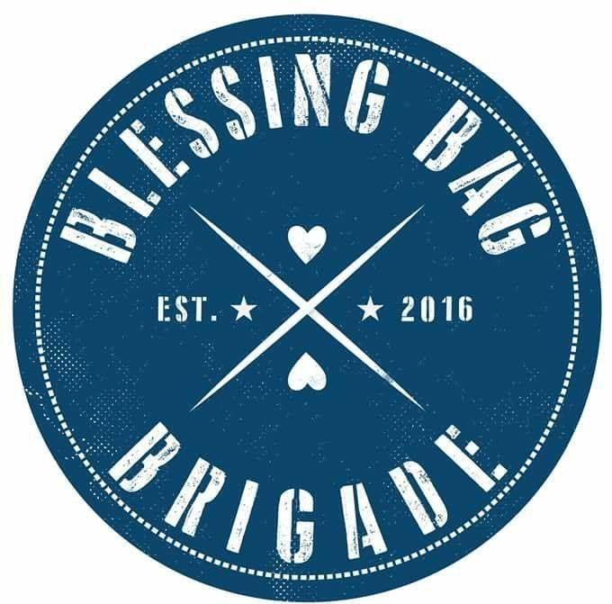

SPONSORSHIP OPPORTUNITIES
Cocktails for a Cause
March 6, 2020
Platinum Sponsor- Logo on Step and Repeat, Name on inside cover or back cover of Ad book, Scrolling Ad on T.V.’s on night of event, Top billing on website sponsor page, and 2 tickets to event.
$1,000
Gold Sponsor- Full page ad in Ad book, Scrolling Ad on T.V.’s on night of event, Info on website sponsor page 1 ticket to event.
$500
Silver Sponsor- Full page ad in Ad book, Scrolling Ad on T.V.’s on night of event.
$100
Bronze Sponsor- ½ Page ad in Ad book
$50

Sponsorship level___________________ Amount enclosed______________
Please forward images and information for the Ad pages to BlessingBagBrigadeNJ@gmail.com
SPONSORSHIP DEADLINE February 24, 2020
Visit us at: BlessingBagBrigadeNJ.org
Email: BlessingBagBrigadeNJ@gmail.com
Phone (347) 938-0054

